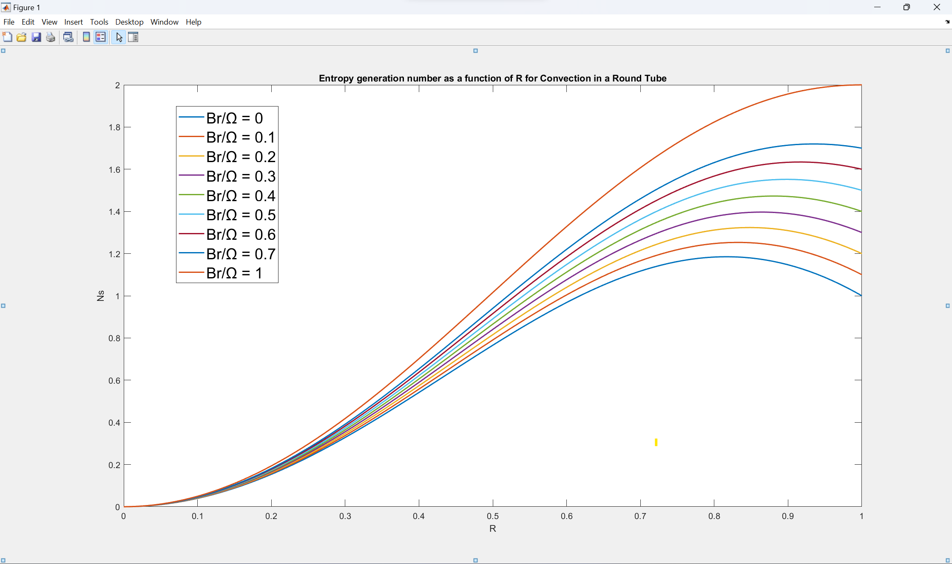**MATLAB CODE**

R = linspace(0,1,100);

plot(R,(R.^3 - 2*R).^2 + 0*R.^2,LineWidth=1.5);

xlabel('R')

ylabel('Ns')

title(['Entropy generation number as a function of R for Convection in a Round Tube'])

hold on

plot(R,(R.^3 - 2*R).^2 + 0.1*R.^2,LineWidth=1.5);

plot(R,(R.^3 - 2*R).^2 + 0.2*R.^2,LineWidth=1.5);

plot(R,(R.^3 - 2*R).^2 + 0.3*R.^2,LineWidth=1.5);

plot(R,(R.^3 - 2*R).^2 + 0.4*R.^2,LineWidth=1.5);

plot(R,(R.^3 - 2*R).^2 + 0.5*R.^2,LineWidth=1.5);

plot(R,(R.^3 - 2*R).^2 + 0.6*R.^2,LineWidth=1.5);

plot(R,(R.^3 - 2*R).^2 + 0.7*R.^2,LineWidth=1.5);

plot(R,(R.^3 - 2*R).^2 + 01*R.^2,LineWidth=1.5);

hold off

legend("Br/Ω = 0","Br/Ω = 0.1","Br/Ω = 0.2","Br/Ω = 0.3","Br/Ω = 0.4","Br/Ω = 0.5","Br/Ω = 0.6","Br/Ω = 0.7","Br/Ω = 1")

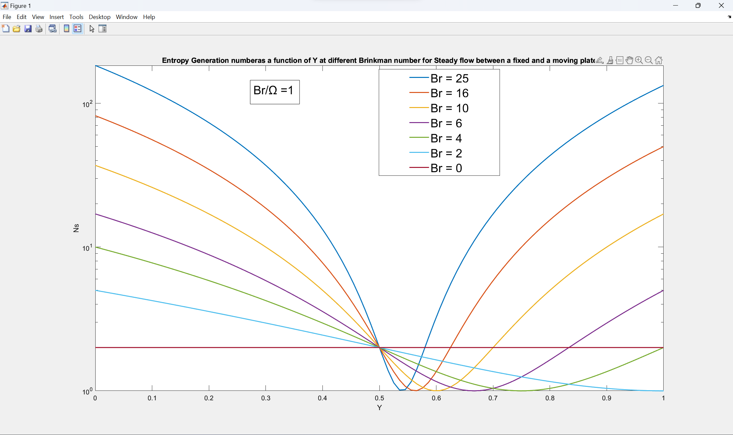**MATLAB CODE**

Y = linspace(0,1,100);

semilogy(Y,(1+(25./2)-25*Y).^2 +1,LineWidth=1.5)

xlabel('R')

ylabel('Ns')

title('Entropy Generation numberas a function of Y at different Brinkman number for Steady flow between a fixed and a moving plate')

hold on

plot(Y,(1+(16./2)-16*Y).^2 +1,LineWidth=1.5)

plot(Y,(1+(10./2)-10*Y).^2 +1,LineWidth=1.5)

plot(Y,(1+(6./2)-6*Y).^2 +1,LineWidth=1.5)

plot(Y,(1+(4./2)-4*Y).^2 +1,LineWidth=1.5)

plot(Y,(1+(2./2)-2*Y).^2 +1,LineWidth=1.5)

plot(Y,(1+(0./2)-0*Y).^2 +1,LineWidth=1.5)

hold off

legend("Br = 25","Br = 16","Br = 10","Br = 6","Br = 4","Br = 2","Br = 0")

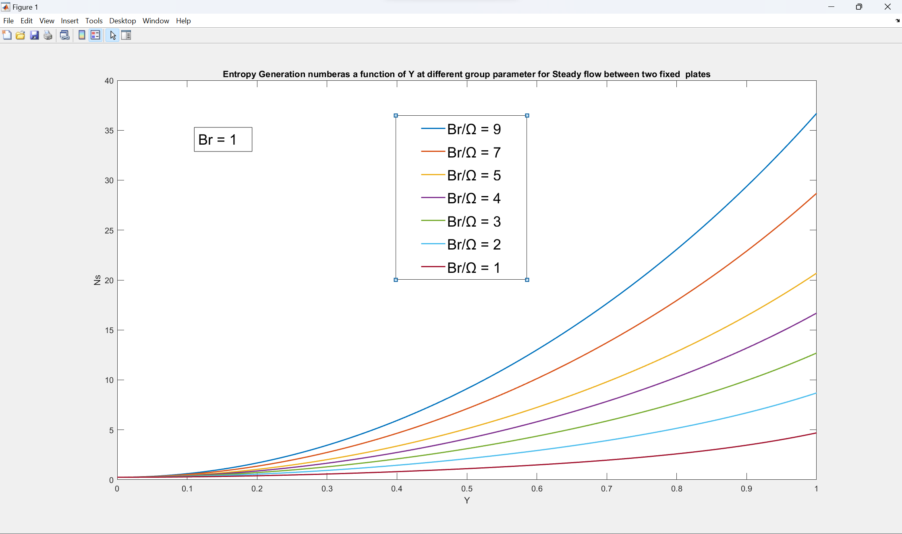

**MATLAB CODE**

Y = linspace(0,1,100);

plot(Y,(0.5-1.3333*Y.^3).^2+4*Y.^2*9,LineWidth=1.5);

xlabel('Y')

ylabel('Ns')

title('Entropy Generation number as a function of Y at different group parameter for Steady flow between two fixed plates')

hold on

plot(Y,(0.5-1.3333*Y.^3).^2+4*Y.^2*7,LineWidth=1.5);

plot(Y,(0.5-1.3333*Y.^3).^2+4*Y.^2*5,LineWidth=1.5);

plot(Y,(0.5-1.3333*Y.^3).^2+4*Y.^2*4,LineWidth=1.5);

plot(Y,(0.5-1.3333*Y.^3).^2+4*Y.^2*3,LineWidth=1.5);

plot(Y,(0.5-1.3333*Y.^3).^2+4*Y.^2*2,LineWidth=1.5);

plot(Y,(0.5-1.3333*Y.^3).^2+4*Y.^2*1,LineWidth=1.5);

hold off

legend("Br/Ω = 9","Br/Ω = 7","Br/Ω = 5","Br/Ω = 4","Br/Ω = 3","Br/Ω = 2","Br/Ω = 1")

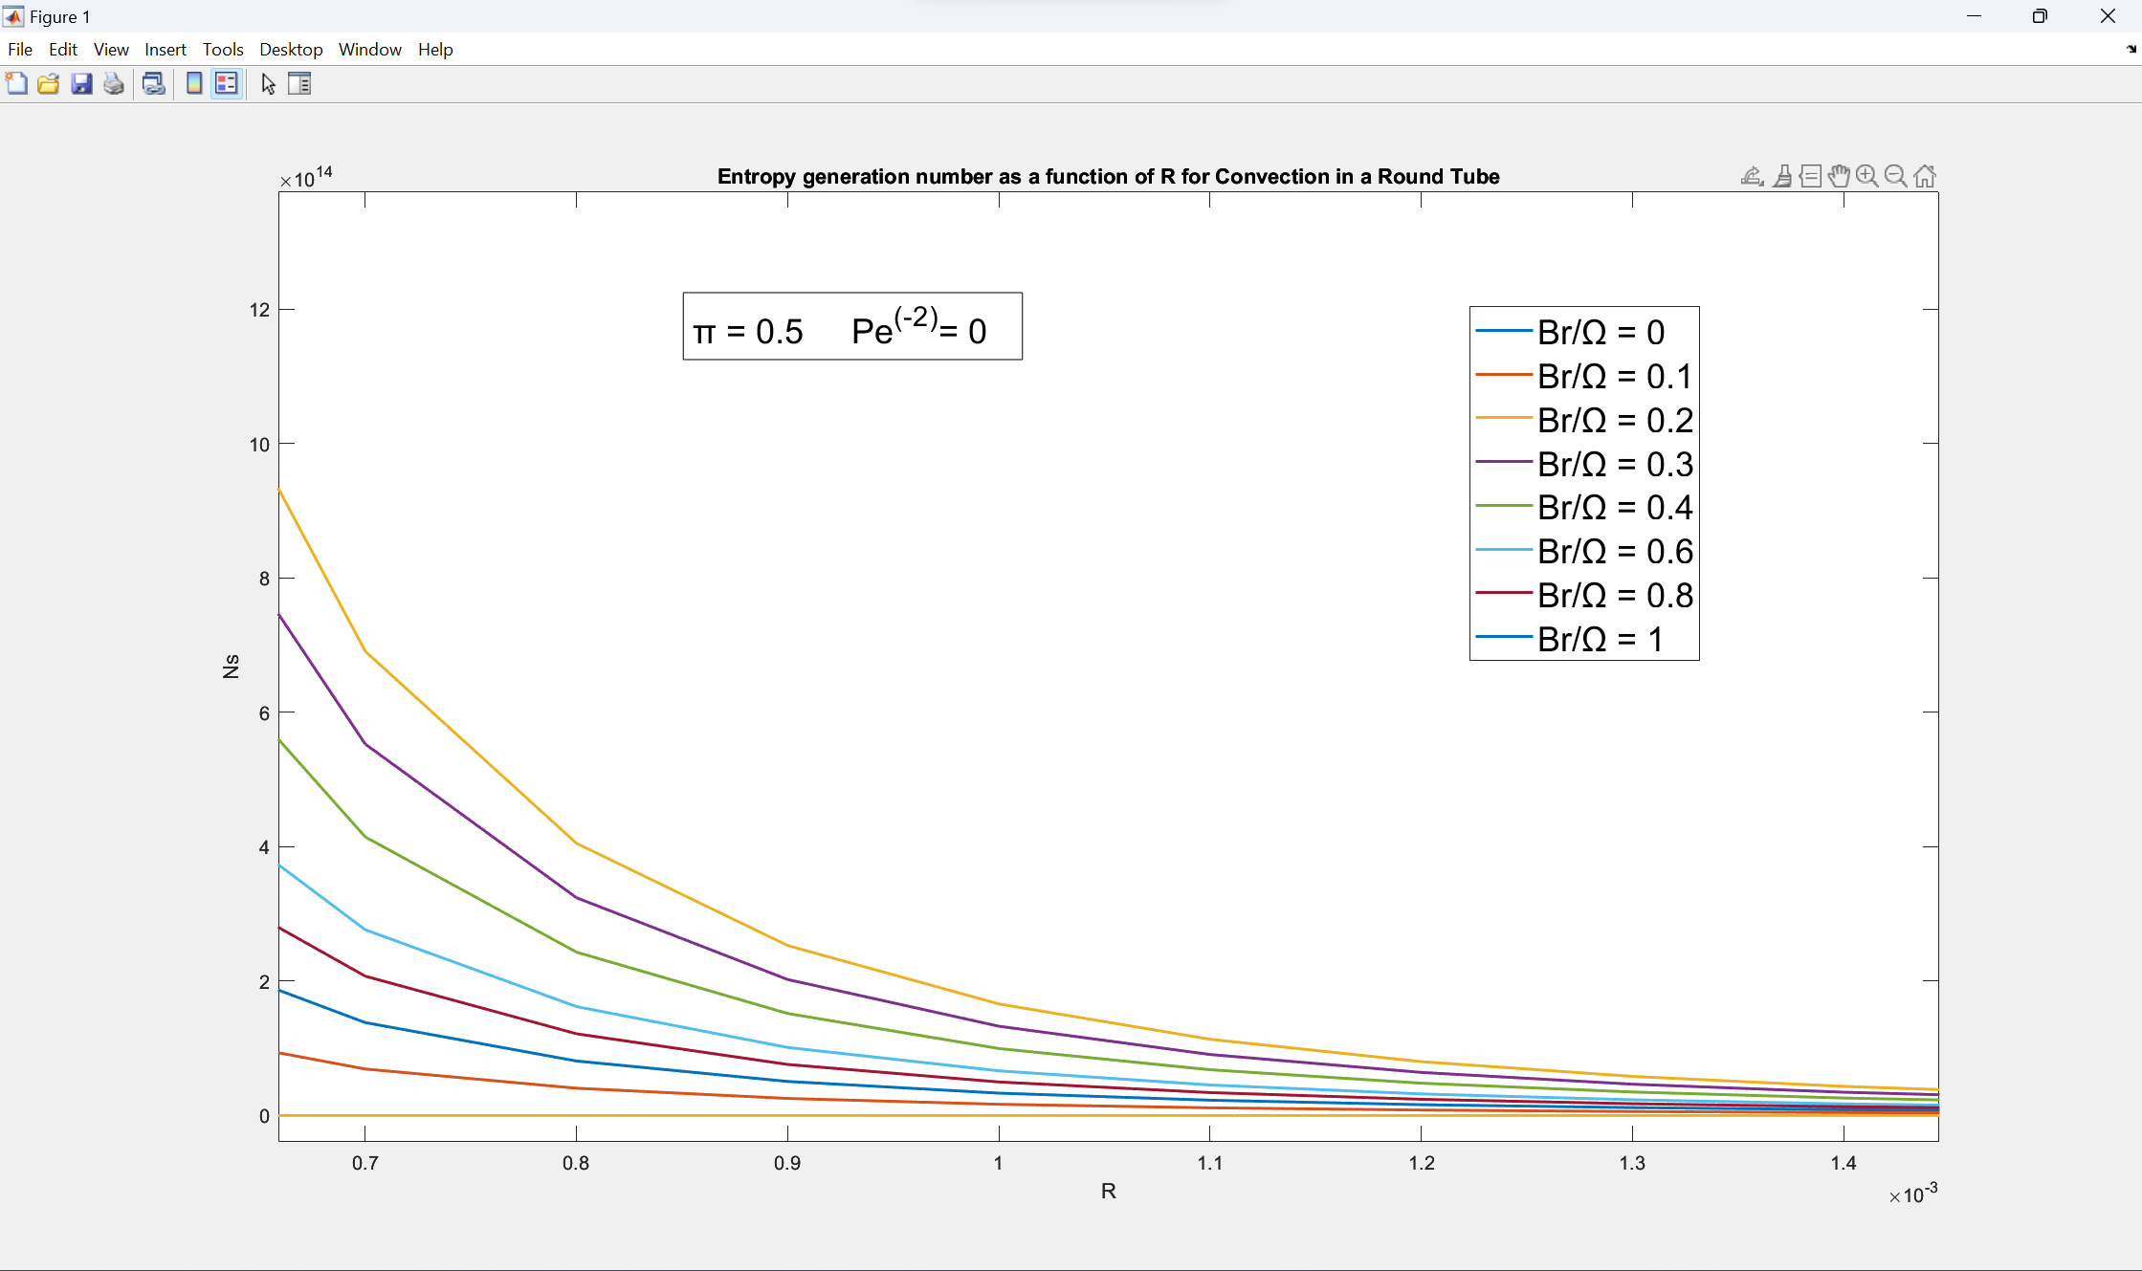

**Matlab Code**

c1 =0.167978719;

c2 = 1.08202128;

R = linspace(0,1,10000);

plot(R,(((2*R.*(1+(c2*log(R))-c2))/(c2-1) + (c2*R-R.^3)/(c2-1))).^2 + 4*1*((2*R-(c2./(R.^2))).^2)./(c1^2),LineWidth=1.5)

xlabel('R')

ylabel('Ns')

title(['Entropy generation number as a function of R for',' Convection in a Round Tube'])

hold on

plot(R,(((2*R.*(1+(c2*log(R))-c2))/(c2-1) + (c2*R-R.^3)/(c2-1))).^2 + 4*0.8*((2*R-(c2./(R.^2))).^2)./(c1^2),LineWidth=1.5)

plot(R,(((2*R.*(1+(c2*log(R))-c2))/(c2-1) + (c2*R-R.^3)/(c2-1))).^2 + 4*0.6*((2*R-(c2./(R.^2))).^2)./(c1^2),LineWidth=1.5)

plot(R,(((2*R.*(1+(c2*log(R))-c2))/(c2-1) + (c2*R-R.^3)/(c2-1))).^2 + 4*0.4*((2*R-(c2./(R.^2))).^2)./(c1^2),LineWidth=1.5)

plot(R,(((2*R.*(1+(c2*log(R))-c2))/(c2-1) + (c2*R-R.^3)/(c2-1))).^2 + 4*0.3*((2*R-(c2./(R.^2))).^2)./(c1^2),LineWidth=1.5)

plot(R,(((2*R.*(1+(c2*log(R))-c2))/(c2-1) + (c2*R-R.^3)/(c2-1))).^2 + 4*0.2*((2*R-(c2./(R.^2))).^2)./(c1^2),LineWidth=1.5)

plot(R,(((2*R.*(1+(c2*log(R))-c2))/(c2-1) + (c2*R-R.^3)/(c2-1))).^2 + 4*0.1*((2*R-(c2./(R.^2))).^2)./(c1^2),LineWidth=1.5)

plot(R,(((2*R.*(1+(c2*log(R))-c2))/(c2-1) + (c2*R-R.^3)/(c2-1))).^2 + 4*0*((2*R-(c2./(R.^2))).^2)./(c1^2),LineWidth=1.5)

hold off

legend("Br/Ω = 0","Br/Ω = 0.1","Br/Ω = 0.2","Br/Ω = 0.3","Br/Ω = 0.4","Br/Ω = 0.6","Br/Ω = 0.8","Br/Ω = 1")

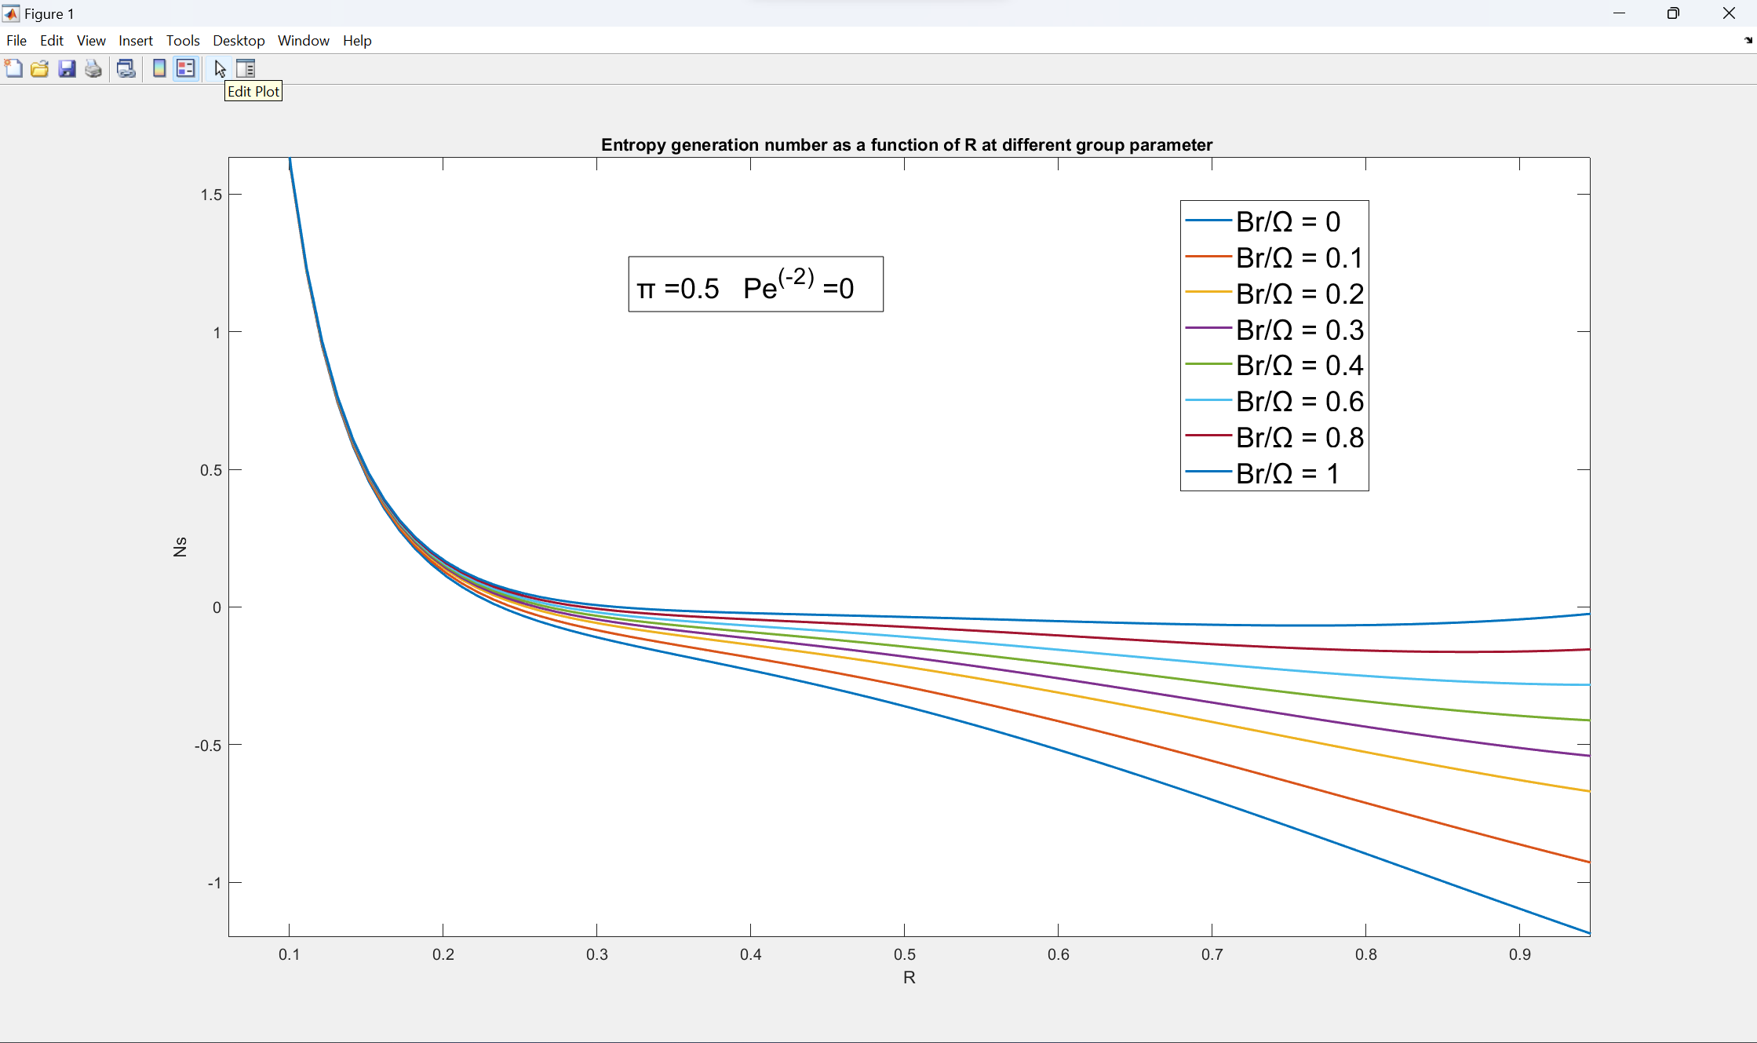**matlab code**

R = linspace(0,1,100);

plot(R,(0.25./R + R.*(2*log(R./0.5)-1)).^2./(0.25 - 2*log(0.5)+1)+ 0.5*1./((-0.3465736./R.^2)),LineWidth=1.5)

xlabel('R')

ylabel('Ns')

title('Entropy generation number as a function of R at different group parameter ')

hold on

plot(R,(0.25./R + R.*(2*log(R./0.5)-1)).^2./(0.25 - 2*log(0.5)+1)+ 0.5*0.8./((-0.3465736./R.^2)),LineWidth=1.5)

plot(R,(0.25./R + R.*(2*log(R./0.5)-1)).^2./(0.25 - 2*log(0.5)+1)+ 0.5*0.6./((-0.3465736./R.^2)),LineWidth=1.5)

plot(R,(0.25./R + R.*(2*log(R./0.5)-1)).^2./(0.25 - 2*log(0.5)+1)+ 0.5*0.5./((-0.3465736./R.^2)),LineWidth=1.5)

plot(R,(0.25./R + R.*(2*log(R./0.5)-1)).^2./(0.25 - 2*log(0.5)+1)+ 0.5*0.4./((-0.3465736./R.^2)),LineWidth=1.5)

plot(R,(0.25./R + R.*(2*log(R./0.5)-1)).^2./(0.25 - 2*log(0.5)+1)+ 0.5*0.3./((-0.3465736./R.^2)),LineWidth=1.5)

plot(R,(0.25./R + R.*(2*log(R./0.5)-1)).^2./(0.25 - 2*log(0.5)+1)+ 0.5*0.2./((-0.3465736./R.^2)),LineWidth=1.5)

plot(R,(0.25./R + R.*(2*log(R./0.5)-1)).^2./(0.25 - 2*log(0.5)+1)+ 0.5*0.1./((-0.3465736./R.^2)),LineWidth=1.5)

hold off

legend("Br/Ω = 0","Br/Ω = 0.1","Br/Ω = 0.2","Br/Ω = 0.3","Br/Ω = 0.4","Br/Ω = 0.6","Br/Ω = 0.8","Br/Ω = 1")

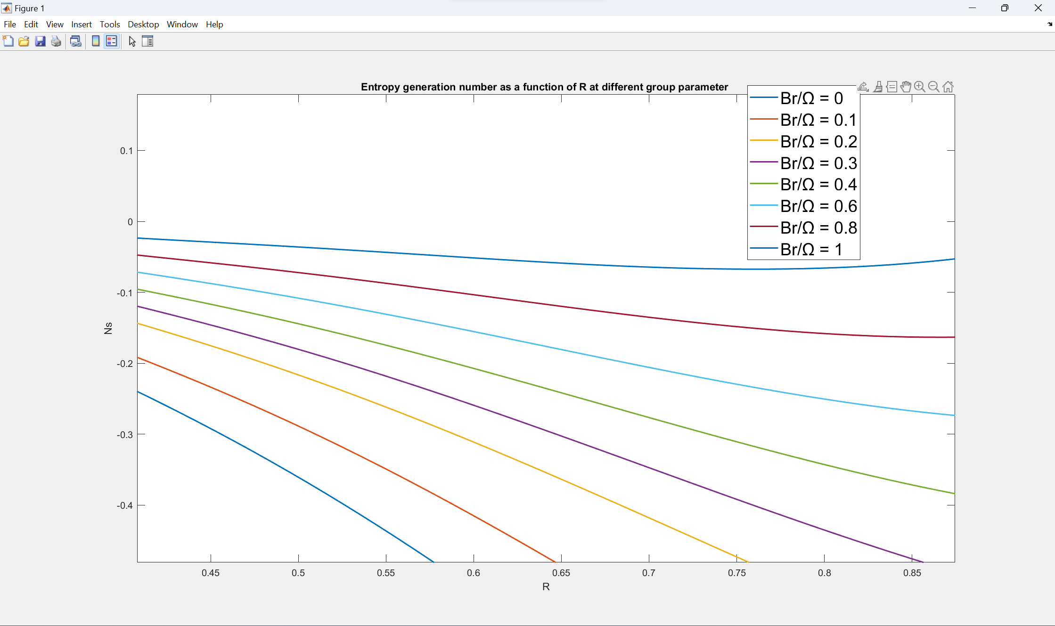**matlab code**

R = linspace(0,1,100);

plot(R,-0.4328085.*log(R)./(R.^3) -0.865617*(1-(0.25./R.^2)./R +1.4427./R+1*0.00000016.*R.^4),LineWidth=1.5)

xlabel('R')

ylabel('Ns')

title('Entropy generation number as a function of R at different group parameter ')

hold on

plot(R,-0.4328085.*log(R)./(R.^3) -0.865617*(1-(0.25./R.^2)./R +1.4427./R+0.8*0.00000016.*R.^4),LineWidth=1.5)

plot(R,-0.4328085.*log(R)./(R.^3) -0.865617*(1-(0.25./R.^2)./R +1.4427./R+0.6*0.00000016.*R.^4),LineWidth=1.5)

plot(R,-0.4328085.*log(R)./(R.^3) -0.865617*(1-(0.25./R.^2)./R +1.4427./R+0.5*0.00000016.*R.^4),LineWidth=1.5)

plot(R,-0.4328085.*log(R)./(R.^3) -0.865617*(1-(0.25./R.^2)./R +1.4427./R+0.4*0.00000016.*R.^4),LineWidth=1.5)

plot(R,-0.4328085.*log(R)./(R.^3) -0.865617*(1-(0.25./R.^2)./R +1.4427./R+0.2*0.00000016.*R.^4),LineWidth=1.5)

plot(R,-0.4328085.*log(R)./(R.^3) -0.865617*(1-(0.25./R.^2)./R +1.4427./R+0.1*0.00000016.*R.^4),LineWidth=1.5)

plot(R,-0.4328085.*log(R)./(R.^3) -0.865617*(1-(0.25./R.^2)./R +1.4427./R+0*0.00000016.*R.^4),LineWidth=1.5)